Report Of
ADH ID GENERATION SOFTWARE
By ADH Enterprises

Submitted To
School of Computer Science and Engineering
IILM University, Greater Noida, U.P.

In partial fulfilment of the requirement of degree of
B.Tech CSE

By
Roll Number of Student: 25SCS1003005409
Name of Student: Modassir Husain
Year / Semester: 2nd Year, 3rd Semester
Batch: 2026–27

CANDIDATE'S DECLARATION
I, Modassir Husain, hereby declare that the internship report titled “ADH ID Generation Software” has been prepared by me as a part of my internship and in partial fulfilment of the requirements for the award of the degree of Bachelor of Technology in Computer Science and Engineering.
During my internship at ADH Enterprises, I worked as a Front-End Designer Intern on the ADH ID Generation Software. My work was mainly focused on the user-facing and visual side of the product, including helping design the interface, planning layouts, arranging different sections, and improving the overall presentation and usability of the application.
The information presented in this report is based on my work, learning, and experience during the internship. I confirm that this report has been prepared for academic submission and has not been submitted to any other institution for the award of any degree or diploma.

ACKNOWLEDGEMENT
I would like to sincerely thank everyone who supported and guided me during my internship at ADH Enterprises.
This internship gave me an opportunity to understand how the design of a software product is planned and developed in a practical environment. Working on the ADH ID Generation Software helped me understand that a good application is not only about its functionality, but also about how clearly and comfortably users can interact with it.
I am especially thankful to my mentors and team members for involving me in the design and development discussions. Their guidance helped me understand the requirements of the product and allowed me to contribute to its front-end design, layout, visual structure, and overall user experience.
I am also grateful to the School of Computer Science and Engineering, IILM University, for providing me with the opportunity to undertake this internship and gain practical experience beyond the classroom.
Finally, I would like to thank my parents, friends, and everyone who supported and encouraged me throughout the internship.

INTERNSHIP COMPLETION CERTIFICATE
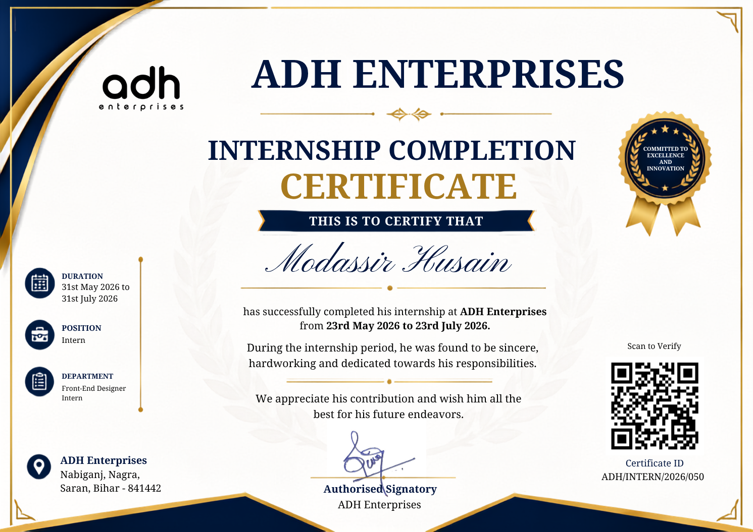

Certificate Holder: Modassir Husain
Organization: ADH Enterprises
Internship Role: Front-End Designer Intern
Internship Period: 31st May 2026 to 31st July 2026

PROJECT DESCRIPTION
4.1 INTRODUCTION
During my internship, I got the opportunity to work on a software product called ADH ID Generation Software. The main purpose of the product was to make the process of managing information and generating identification cards more organized and convenient.
My role in the project was mainly as a Front-End Designer Intern. I was involved in the user-facing side of the product and worked on how the application should look, how different sections should be arranged, and how users should interact with the interface.
I contributed to the planning and design of layouts, the arrangement of different elements on screens, and the overall visual presentation of the product. This helped me understand how design decisions can affect the clarity and usability of a software application.
4.2 ORGANIZATION PROFILE
ADH Enterprises is an organization working in the areas of printing, designing, and digital solutions. During my internship, I had the opportunity to work with the team on the ADH ID Generation Software.
The internship provided me with practical exposure to a real working environment where product requirements, design ideas, and development work were discussed and refined.
Working with the team helped me understand how a front-end designer contributes to a software product and how visual design, layout, and user flow are considered while developing an application.
4.3 PROBLEM STATEMENT
Managing and generating ID cards can become difficult when a large number of records and different types of information have to be handled. Apart from managing the information, the application also needs a clear interface through which users can understand the available options and complete their work comfortably.
A poorly organized interface can make even a useful system difficult to use. Therefore, the ADH ID Generation Software required a clear and organized front-end structure that could present the different activities of the product in an understandable way.
The project focused on creating a structured interface and layout so that the overall ID-generation process could be presented in a simple and user-friendly manner.
4.4 PROJECT OBJECTIVES
- Create a clear and user-friendly front-end for the ID generation product.
- Plan suitable layouts for different sections of the application.
- Organize interface elements in a simple and understandable manner.
- Maintain consistency in the visual presentation of the product.
- Make the user workflow easier to understand through appropriate screen arrangement.
- Improve the overall usability and presentation of the application.
- Create a front-end structure that can be improved as the product develops.
My main contribution was focused on the front-end design and the visual and structural aspects of the product.
4.5 SCOPE OF THE PROJECT
The scope of the project includes the design and development of a structured interface for an ID generation software product. My area of work mainly covered:
- Front-end interface design.
- Planning and arranging screen layouts.
- Designing the visual structure of different sections.
- Organizing buttons, forms, information, and other interface elements.
- Considering the user flow while planning the interface.
- Refining the presentation of the product based on feedback.
4.6 TECHNOLOGIES AND TOOLS USED
During the internship, I worked around front-end design and development tools used for creating and refining the user-facing parts of the product. My practical exposure was mainly related to front-end design, user interface work, layout design, and testing and refinement.
- Front-End Design – planning the visual appearance and structure of the application.
- User Interface Work – arranging and refining the elements users interact with.
- Layout Design – deciding how information and controls should be presented on different screens.
- Testing and Refinement – reviewing the interface and making improvements based on product requirements.
4.7 SYSTEM / INTERFACE STRUCTURE
The front-end structure of the product was planned around a simple user flow. The interface needed to guide users through the required activities without making the application unnecessarily complicated.
USER
↓
MAIN INTERFACE
↓
DATA / INFORMATION SCREENS
↓
DESIGN & LAYOUT
↓
ID GENERATION
My contribution was mainly related to how these sections should be presented to the user. I helped in thinking about the arrangement of screens and interface elements so that the product could remain clear, consistent, and easy to navigate.

4.8 METHODOLOGY
My work during the internship followed a practical design-and-refinement approach. The main stages of my involvement were:
1. Understanding the Product
I focused on understanding the purpose of the ADH ID Generation Software and the type of users who would interact with it.
2. Layout Planning
I contributed to discussions about how different screens and sections should be arranged so the interface remained organized.
3. Front-End Design
I helped in designing and developing parts of the user-facing interface and converting planned layouts into the product.
4. User Flow and Usability
I considered how users would move from one section to another and helped refine the interface so the workflow remained understandable.
5. Review and Refinement
The interface was reviewed during development and changes were made where necessary based on requirements and feedback.
4.9 EXPECTED OUTCOMES
The expected outcome of the project was a clean, organized, and user-friendly front-end for the ADH ID Generation Software.
From my internship perspective, I gained practical understanding in the following areas:
- Understanding how the visual side of a software product is planned.
- Designing and arranging user-facing interfaces.
- Planning layouts according to product requirements.
- Understanding the relationship between interface design and user workflow.
- Improving designs through feedback and refinement.
- Working with a team while contributing to a real software product.
The internship helped me understand that a good front-end is not only about making an application look attractive. It should also make the product easier to understand, navigate, and use.
4.10 CERTIFICATES OF COMPLETION AND OTHER COMMUNICATION
The Internship Completion Certificate issued by ADH Enterprises is attached with this report. Any relevant internship-related communication or supporting documents may also be attached in this section, if required.

BIBLIOGRAPHY / REFERENCES
1. Documentation and learning resources referred to during the front-end design and development of the ADH ID Generation Software.
2. Internal project discussions and guidance received during the internship.
3. Design and front-end development references consulted during the internship.

